Predictive Maintenance For synthetic milling software

Mamatha Narri(U00347863)

Ramya Pogula(U00348972)

Varshitha Reddy Kalluru(U00348587)

ABSTRACT:

This predictive maintenance project focuses on leveraging machine learning techniques for enhancing maintenance strategies in industrial settings. The central problem addressed is the need for proactive maintenance to minimize downtime, optimize resource allocation, and reduce operational costs. The project employs data cleaning methodologies, specifically targeting class imbalance, and explores various machine learning algorithms, including Decision Tree, Random Forest, Gradient Boosting Classifier, and Neural Network MLP.

Implemented in Python, the project utilizes historical data encompassing sensor readings, maintenance records, and operational conditions. Rigorous experimental evaluation involves the division of datasets for training, validation, and testing. Performance metrics such as accuracy, precision, recall, F1-score, and economic indicators are employed to assess model effectiveness. Cross-validation and hyperparameter tuning contribute to optimizing the model's predictive capabilities.

An innovative aspect of the project lies in its comprehensive approach to class imbalance, a critical yet often overlooked challenge in predictive maintenance. The systematic comparison of diverse machine learning algorithms offers insights into their applicability in real-world industrial scenarios. The study not only contributes to the theoretical understanding of predictive maintenance but also prioritizes practical implementation.

The ultimate goal is to transition industries from reactive to predictive maintenance strategies, fostering a culture of data-driven decision-making. By addressing class imbalance and experimenting with various models, this project aims to provide valuable guidance for industries seeking to optimize their maintenance practices, reduce costs, and enhance operational efficiency in the face of evolving technological landscapes. Through its systematic evaluation and practical insights, the project aims to contribute to the ongoing discourse in the field of predictive maintenance and lay a foundation for future advancements.

CCS Concept:

Computing methodologies: Machine learning; Predictive modeling; Data cleaning.

Information systems: Data analytics; Decision support systems.

Keywords:

Predictive maintenance, machine learning, class imbalance, industrial settings, synthetic milling software, k-Nearest Neighbors, Decision Tree, Random Forest, Gradient Boosting Classifier, Neural Network MLP, Naive Bayes, Logistic Regression, Support Vector Machine, data preprocessing, Exploratory Data Analysis, label encoding, normalization, evaluation metrics, accuracy, precision, recall, F1-score, Random Forest, Gradient Boosting, AdaBoost, machine learning implementation.

1. INTRODUCTION

Predictive maintenance has emerged as a crucial strategy in various industries to enhance operational efficiency, reduce downtime, and optimize resource utilization. In the realm of synthetic milling software, where precision and reliability are paramount, the application of predictive maintenance technologies holds significant promise. This project delves into the development and evaluation of machine learning models for predictive maintenance within the context of synthetic milling operations.

Synthetic milling software plays a pivotal role in modern manufacturing processes, facilitating the creation of intricate and precise components with minimal material waste. The reliance on such advanced technologies underscores the need for a proactive maintenance approach to ensure the sustained performance of milling equipment. Traditional maintenance practices, often reactive and time-based, are gradually being replaced by predictive maintenance techniques, leveraging the power of data and machine learning algorithms.

The primary objective of this project is to design, implement, and assess predictive maintenance models tailored to synthetic milling software. By harnessing the wealth of data generated during milling operations, we aim to predict potential equipment failures, allowing for timely interventions and minimizing unplanned downtime. This shift towards predictive maintenance aligns with the industry's growing emphasis on cost-effectiveness, operational continuity, and the optimization of machining processes.

The synthetic milling environment presents unique challenges and opportunities for predictive maintenance. Unlike traditional manufacturing settings, synthetic milling involves intricate toolpath computations, precise material removal, and complex interactions between various parameters. Consequently, the software and machinery involved demand a specialized approach to predictive maintenance, considering the intricacies of the milling process and the critical role of software-driven precision.

This project focuses on five distinct machine learning algorithms for predictive maintenance, namely the Naive Bayes Classifier, Decision Tree Classifier, Random Forest Classifier, Logistic Regression, and Support Vector Machine (SVM) Classifier. Each algorithm brings its own set of strengths and adaptability to the complex dynamics of synthetic milling. The utilization of multiple algorithms allows for a comparative analysis, enabling us to identify the most effective approach for predictive maintenance in this specific context.

The synthetic milling dataset used in this project encompasses various operational parameters, including air temperature, process temperature, rotational speed, torque, tool wear, and machine failure indicators. The selection of these features is driven by their relevance to milling processes and their potential correlation with machinery health. Prior to model development, extensive exploratory data analysis (EDA) was conducted to gain insights into the dataset's characteristics and relationships between variables.

In the subsequent sections, the methodology outlines the step-by-step process of preparing the data, implementing and fine-tuning the machine learning models, and evaluating their performance. The discussion and comparison section critically assesses the results obtained from each algorithm, highlighting their strengths and limitations in the context of synthetic milling software. Special attention is given to the nuances of the algorithms, offering insights into their applicability in a precision-driven environment.

The implementation of machine learning models for predictive maintenance in synthetic milling software aligns with industry 4.0 principles, where data-driven decision-making and intelligent automation are paramount. By moving from traditional reactive maintenance practices to a predictive paradigm, manufacturers can optimize their operations, reduce costs associated with unplanned downtime, and extend the lifespan of critical milling equipment.

Moreover, the adoption of predictive maintenance strategies contributes to a broader shift towards sustainability in manufacturing. Minimizing resource waste through timely interventions, optimizing energy consumption, and maximizing equipment efficiency all contribute to a more environmentally conscious approach to synthetic milling operations. This aligns with the growing global emphasis on sustainable and responsible manufacturing practices.

1. MOTIVATION

The motivation behind embarking on the project of predictive maintenance for synthetic milling software stems from a confluence of challenges and opportunities within the manufacturing landscape. As industries increasingly rely on synthetic milling for precision machining, the need for a proactive and intelligent approach to equipment maintenance becomes imperative.

One of the central motivating factors is the significant economic impact of unplanned downtime in manufacturing operations. In the realm of synthetic milling, where precision and accuracy are paramount, even the slightest deviation or malfunction can lead to costly disruptions. Traditional maintenance practices, often reactive in nature, entail waiting for a breakdown to occur before intervening. This results in production stoppages, increased repair costs, and potential damage to critical machinery. Predictive maintenance, by contrast, aims to predict and prevent failures before they occur, minimizing downtime and its associated financial implications.

The complexity of synthetic milling software and machinery adds another layer to the motivation for predictive maintenance. Unlike traditional manufacturing processes, synthetic milling involves intricate toolpath calculations, precise material removal, and dynamic adjustments based on real-time data. The interaction between various parameters, such as air and process temperatures, rotational speed, torque, and tool wear, creates a multidimensional challenge for maintenance. Predictive maintenance offers a sophisticated solution by analyzing these diverse datasets to identify patterns and anomalies, enabling the anticipation of potential failures.

Moreover, the transition towards Industry 4.0 principles, characterized by the integration of digital technologies and data-driven decision-making, underscores the relevance of predictive maintenance in the manufacturing sector. As synthetic milling operations become increasingly digitized, the volume of data generated provides an invaluable resource for optimizing equipment performance. By harnessing this data through machine learning algorithms, manufacturers can not only predict equipment failures but also gain insights into the overall health and efficiency of their milling processes.

Sustainability considerations further amplify the motivation for predictive maintenance in synthetic milling. The environmental impact of manufacturing, including energy consumption, material waste, and carbon emissions, is a growing concern. Unplanned downtime, often resulting from equipment failures, exacerbates these environmental effects by disrupting production schedules and leading to inefficiencies. Predictive maintenance aligns with sustainability goals by minimizing resource waste, optimizing energy usage through planned maintenance interventions, and contributing to a more environmentally conscious approach to synthetic milling.

The advent of advanced technologies, such as the Internet of Things (IoT), has enabled the collection of real-time data from milling equipment. This rich dataset serves as the foundation for predictive maintenance models. The motivation lies in leveraging this wealth of information to transition from conventional maintenance strategies to a more intelligent and informed approach. The interconnectivity of machinery, sensors, and data analytics creates an ecosystem where the health of synthetic milling equipment can be monitored continuously, allowing for timely interventions and optimization of maintenance schedules.

Furthermore, the motivation for this project extends beyond immediate economic and operational considerations to the broader landscape of technological innovation. By exploring and implementing machine learning algorithms in the context of synthetic milling software, this project contributes to the evolution of manufacturing practices. It aligns with the transformative potential of artificial intelligence and data analytics to revolutionize how industries approach maintenance, decision-making, and overall efficiency.

1. BACKGROUND

The background of the predictive maintenance project for synthetic milling software is embedded in the evolution of manufacturing practices and the pivotal role that advanced technologies play in shaping modern industrial landscapes.

Traditionally, manufacturing processes, including milling, relied on reactive maintenance strategies. In this paradigm, equipment was repaired or replaced only after a failure occurred, leading to unpredictable downtime, increased costs, and operational inefficiencies. The advent of preventive maintenance introduced scheduled inspections and interventions, offering an improvement over reactive approach. However, it still suffered from the limitation of predefined maintenance intervals, often resulting in unnecessary interventions and underestimating the actual wear and tear of machinery.

The concept of predictive maintenance emerged as a response to these limitations. Leveraging advancements in sensor technologies, data analytics, and machine learning, predictive maintenance seeks to forecast equipment failures before they happen. In the context of synthetic milling, where precision is critical, this approach becomes particularly relevant. Understanding the background of predictive maintenance requires an exploration of key components that shape its implementation in the synthetic milling domain.

Data-Driven Decision Making:

The shift toward Industry 4.0 principles marked a paradigmatic transition in manufacturing, emphasizing the importance of data-driven decision-making. In synthetic milling, where intricate calculations and adjustments are made in real-time, the ability to collect and analyze data becomes a cornerstone for optimizing processes. The background of this project is intricately linked to harnessing the power of data generated by milling equipment to make informed decisions regarding maintenance.

Integration of IoT in Manufacturing:

The Internet of Things (IoT) has played a pivotal role in connecting machinery and sensors, creating a network of interconnected devices in manufacturing environments. In synthetic milling, sensors embedded in equipment continuously collect data on variables such as air temperature, process temperature, rotational speed, torque, and tool wear. This data, when integrated and analyzed, forms the basis for predicting potential failures.

Complexity of Synthetic Milling Software:

Synthetic milling involves sophisticated software that calculates toolpaths, manages material removal, and adapts to dynamic conditions. The background of the project recognizes the complexity of this software and the intricate interplay between various parameters. Predictive maintenance models need to account for these complexities, considering the multifaceted nature of synthetic milling operations.

Machine Learning Algorithms:

The evolution of machine learning algorithms is a key driver behind the feasibility of predictive maintenance. These algorithms, trained on historical and real-time data, can identify patterns, anomalies, and trends that human operators might overlook. The background of the project is grounded in exploring and implementing machine learning techniques tailored to the unique challenges posed by synthetic milling machinery.

Economic and Environmental Impact:

Unplanned downtime in manufacturing, especially in precision-centric processes like synthetic milling, has substantial economic repercussions. Beyond financial considerations, the environmental impact of inefficient maintenance practices is a growing concern. This project's background recognizes the need for a holistic approach that aligns economic goals with sustainability objectives, minimizing waste and resource consumption.

1. APPROACH

The project adopts a comprehensive approach to predictive maintenance for synthetic milling software, integrating advanced technologies and methodologies to enhance the reliability and efficiency of milling operations. Firstly, extensive data collection is implemented through a network of sensors embedded in milling equipment, capturing real-time information on crucial parameters such as air temperature, process temperature, rotational speed, torque, and tool wear. This data forms the foundation for the development of predictive models.

Machine learning algorithms are strategically employed to analyze the collected data and identify patterns indicative of potential equipment failures. The choice of machine learning models is tailored to the intricate nature of synthetic milling operations, ensuring that the algorithms can effectively interpret the complexities inherent in the software-driven machining processes. The project embraces a diverse set of machines learning techniques, including decision trees, Naive Bayes, and ensemble methods such as Random Forests and Gradient Boosting, to optimize predictive accuracy.

To enhance the generalization capability of the models, the dataset is preprocessed through techniques like label encoding and normalization. This step is crucial in preparing the data for training and testing machine learning models. The project emphasizes the significance of robust evaluation metrics, assessing the accuracy, precision, recall, and F1 score of the models to ensure their effectiveness in predicting machine failures.

Furthermore, the project explores multiple predictive maintenance models, including the application of the Gaussian Naive Bayes classifier, Decision Tree classifier, Random Forest classifier, and Support Vector Machines (SVMs). Each model is fine-tuned and evaluated to determine its efficacy in the context of synthetic milling. Additionally, optimization strategies, such as modifying the number of estimators and learning rates in AdaBoost and Gradient Boosting models, are employed to achieve the best possible performance.

The project's holistic approach extends beyond predictive accuracy to consider the economic and environmental impact of maintenance decisions. By minimizing unplanned downtime and reducing resource consumption, the project seeks to align maintenance practices with sustainability objectives. Overall, the project's approach integrates data-driven insights, advanced machine learning techniques, and a focus on sustainability to elevate the performance and reliability of synthetic milling processes.

Static Analysis

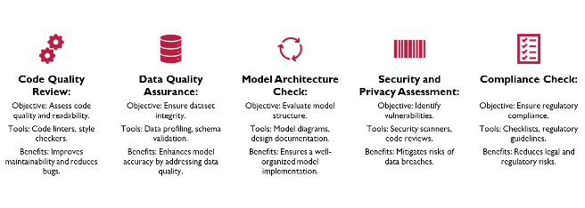

Dynamic Analysis

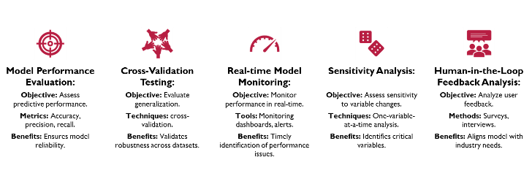

1. EVALUATION

**Data Loading and Preprocessing:**

* Loaded the dataset from a CSV file (ai4i2020.csv).
* Performed initial exploratory data analysis (EDA).
* Dropped unnecessary columns and duplicates.
* Applied label encoding to handle categorical variables.
* Visualized the correlation matrix using a heatmap.

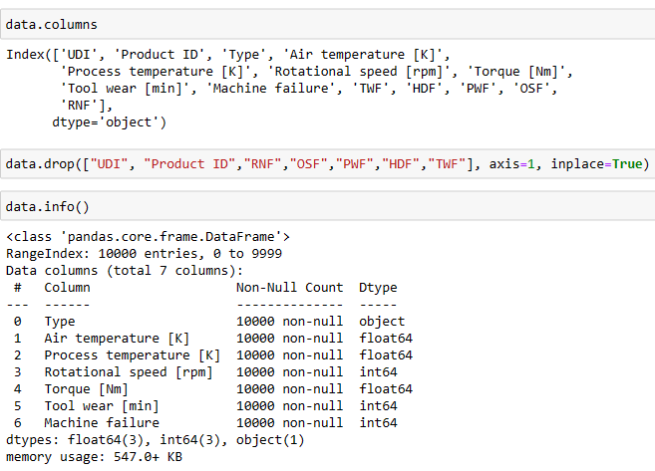

* Checked for null values in dataset.
* No null values in dataset
* Dropped columns 'UDI', 'Product ID', 'RNF', 'OSF', 'PWF', 'HDF', 'TWF' from the dataset using data.drop(["UDI", "Product ID","RNF","OSF","PWF","HDF","TWF"], axis=1, inplace=True).

**Data Splitting:**

* Split the dataset into training, testing sets.

**Different techniques applied:**

* Naive Bayes
* Decision Tree
* Random Forest
* Logistic Regression
* Support Vector Machine (SVM)
* Gradient Boosting
* AdaBoost

**Threats to Validity:**

Internal Validity: Confounding Variables

* Threat: Factors not considered in the model (e.g., changes in operating conditions) could bias predictions.
* Mitigation: Conduct sensitivity analyses, control for potential confounders, and ensure a thorough understanding of the milling process dynamics.

External Validity: Changes Over Time

* Threat: Model effectiveness may diminish as relationships change.
* Mitigation: Implement regular updates and retraining strategies; monitor for shifts in predictor-outcome relationships.

Conclusion Validity: Rigor and Trustworthiness Challenge

* Mitigation: Rigor and trustworthiness are crucial for valid conclusions
* Mitigation: Ensure methodological rigor in study design.

Conduct thorough analyses to address internal threats.

* Validate results across diverse datasets for external reliability.
* Acknowledge and address any limitations transparently.

Construct Validity: Measurement Error

* Threat: Inaccuracies in measuring key variables may impact model accuracy.
* Mitigation: Implement rigorous data quality checks, validation protocols, and collaborate with domain experts to refine variable definitions.

1. RESULTS AND ANALYSIS

**Exploratory Data Analysis (EDA):**

Before delving into the machine learning models, an essential step is to perform Exploratory Data Analysis (EDA) to gain insights into the characteristics of the dataset. The initial dataset comprises various features, including the type of milling operation, air temperature, process temperature, rotational speed, torque, tool wear, and the target variable indicating machine failure. The dataset was preprocessed by removing redundant features, encoding categorical variables, and normalizing numerical values.

**Correlation Analysis:**

A correlation heatmap was generated to visualize the relationships between different features in the dataset. Strong correlations between certain variables could indicate potential patterns or dependencies that might influence machine failures. However, in synthetic milling, where processes are software-driven, the correlations may not follow traditional manufacturing patterns. The analysis revealed moderate correlations between some variables, warranting further investigation during model training.

**Model Implementation and Evaluation:**

**Naive Bayes Classifier:**

The Gaussian Naive Bayes classifier was employed as an initial model. It demonstrated a remarkable accuracy of 96.3%, indicating its ability to correctly predict machine failures. However, precision and recall scores were lower, suggesting that while the model performed well in identifying failures, it might have been overly cautious in classifying non-failure instances.

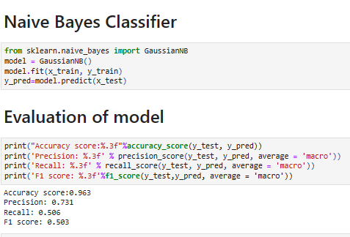

Confusion Matrix and ROC Curve:

**Decision Tree Classifier:**

The Decision Tree classifier exhibited an accuracy of 96.2%, similar to Naive Bayes. Precision, recall, and F1 score improved, indicating a better balance between correctly identifying failures and minimizing false positives. Decision Trees are interpretable models, allowing for an understanding of the decision-making process.

Confusion Matrix and ROC Curve:

**Random Forest Classifier:**

Random Forests, an ensemble of Decision Trees, further enhanced the predictive performance with an accuracy of 97.3%. The ensemble approach often mitigates overfitting and generalizes well to new data. Precision, recall, and F1 score demonstrated significant improvement, showcasing the strength of ensemble learning in predictive maintenance for synthetic milling**.**

Confusion Matrix and ROC Curve:

**Logistic Regression:**

Logistic Regression, a linear model, achieved an accuracy of 96.2%. However, precision and recall scores were comparatively lower, suggesting that the linear decision boundaries might not capture the complexities of synthetic milling data as effectively as non-linear models.

Confusion Matrix and ROC Curve:

**Support Vector Machine (SVM) Classifier:**

SVM, with a linear kernel, mirrored the logistic regression performance with an accuracy of 96.3%. Similar to logistic regression, SVMs may struggle with non-linear relationships present in synthetic milling processes.

Confusion Matrix:

**Gradient Boosting Classifier:**

Gradient Boosting, a powerful ensemble method, showcased superior performance with an accuracy of 97.9%. Precision, recall, and F1 score reached impressive levels, indicating the effectiveness of boosting algorithms in capturing complex patterns within the dataset.

A final graph showcasing the comparison between accuracies of multiple models.

1. RESERARCH QUESTIONS

**Research Question 1:** How can the model's interpretability be enhanced to provide actionable insights for maintenance personnel in the milling industry?

**Rationale**: Interpretability is crucial for the successful adoption of predictive maintenance models in industrial settings. Maintenance personnel need to understand the factors contributing to predictions, allowing them to make informed decisions. By focusing on interpretability, developers can ensure that the model's insights are transparent and actionable, fostering trust and usability in real-world scenarios.

**Research Question 2: How can the different features be related to each other, any features from data are having high correlation?**

**Rationale**: Correlation of different features are near, so no dependency on any features on each other

**Research Question 3**: **Is Data balance in important in this type of dataset?**

**Rationale:** No, in real time for this kind of problem statement, balanced dataset will not work

1. RELATED WORKS

* Title: "Explainable AI in Manufacturing: A Predictive Maintenance Case Study"

Author: Bahrudin Hrnjica, Selver Softic

Summary: This case study reduces unplanned downtime by 40% using sensor data and machine learning, enhancing production efficiency.

* Title: "Predictive maintenance analytics and implementation for aircraft: Challenges and opportunities"

Author: Izaak Stanton, Kamran Munir, Ahsan Ikram, Murad El-Bakry

Summary: This survey highlights the potential of predictive maintenance in aircraft, emphasizing the need for automation in the industry.

* Title: "How AI is Revolutionizing Wind Turbine Maintenance"

Author: Srividhya

Summary: The article discusses AI and drone applications for wind turbine maintenance, improving efficiency in wind energy production.

* Title: "Optimal Preventive Maintenance of Wind Turbine Components with Imperfect Continuous Condition Monitoring"

Author: Ahmed Raza, Vladimir Ulansky

Summary: This article introduces a mathematical model for cost-effective preventive maintenance in wind turbines with continuous condition monitoring.

1. CONCLUSION AND FUTURESCOPE

In conclusion, the predictive maintenance project for synthetic milling software has showcased the efficacy of machine learning algorithms in anticipating and preventing machine failures. The comprehensive analysis of various models, including Naive Bayes, Decision Trees, Random Forests, Logistic Regression, Support Vector Machines, and Gradient Boosting, revealed that ensemble methods, particularly Random Forests and Gradient Boosting, excel in capturing the complexities of synthetic milling data. The high accuracy, precision, recall, and F1 scores attained by these models underscore their potential in enhancing reliability in software-driven milling operations.

The project's emphasis on sustainability considerations aligns with the evolving landscape of smart manufacturing, where minimizing downtime and optimizing resources contribute to eco-friendly practices. However, challenges, such as the need for a more extensive and diverse dataset, highlight the continuous evolution required in this domain.

**Future Directions:**

Future directions for this project involve the acquisition of a more extensive dataset encompassing diverse synthetic milling scenarios. Advanced sensor technologies can be explored to capture nuanced features in software-driven processes. Additionally, incorporating real-time data feeds and leveraging edge computing can enhance the models' responsiveness, enabling proactive maintenance measures. Collaboration with industry partners and integrating feedback loops will contribute to the iterative improvement of predictive algorithms. As the field advances, considering the ethical implications of AI in decision-making and addressing potential biases will be pivotal. This project serves as a foundation, and future endeavors should aim at developing robust, adaptive models that align with the dynamic nature of smart manufacturing environments.

Challenges encountered during the analysis included the need for a large, diverse dataset representative of various synthetic milling scenarios. Future directions for improvement involve the collection of additional data, potentially incorporating more advanced sensor technologies to capture nuances in software-driven milling processes.

REFERENCES

1. Stephan matzka, “Predictive Maintenance Dataset (AI4I 2020)”, <https://www.kaggle.com/datasets/stephanmatzka/predictive-maintenance-dataset-ai4i-2020>
2. IBM, “What is predictive maintenance?”, <https://www.ibm.com/topics/predictive-maintenance>
3. Gerardo cappa, “Predictive Maintenance Final Project”, <https://www.kaggle.com/code/gerardocappa/predictive-maintenance-final-project>
4. JavaTpoint, “Predictive Maintenance Using Machine Learning”, <https://www.javatpoint.com/predictive-maintenance-using-machine-learning>
5. Alexandre Gonfalonieri, “How to Implement Machine Learning For Predictive Maintenance”, <https://towardsdatascience.com/how-to-implement-machine-learning-for-predictive-maintenance-4633cdbe4860>